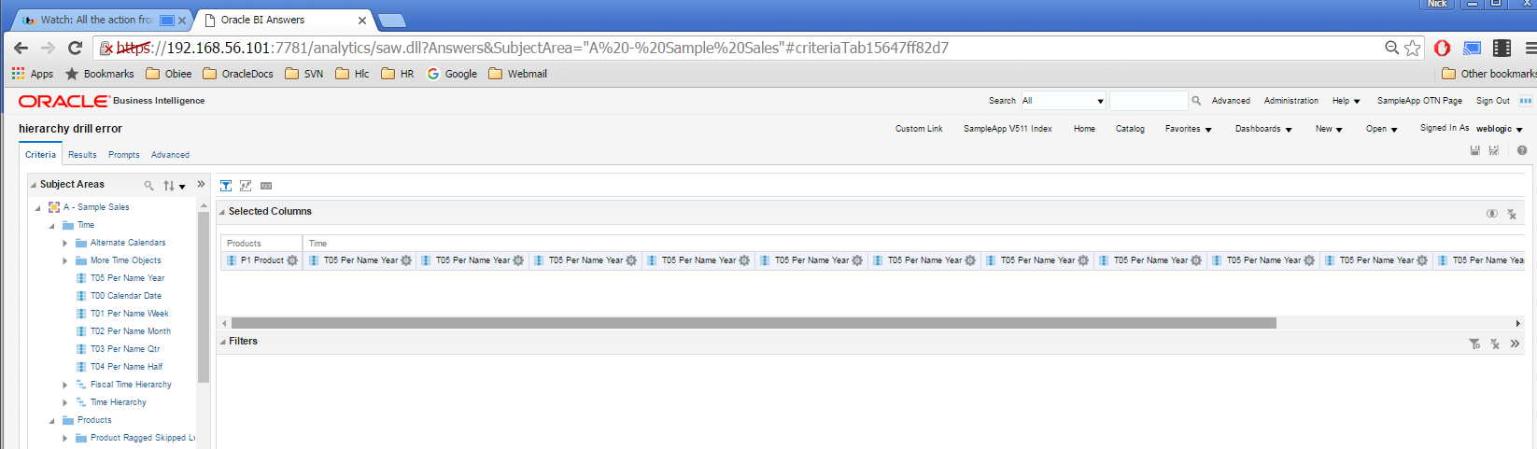

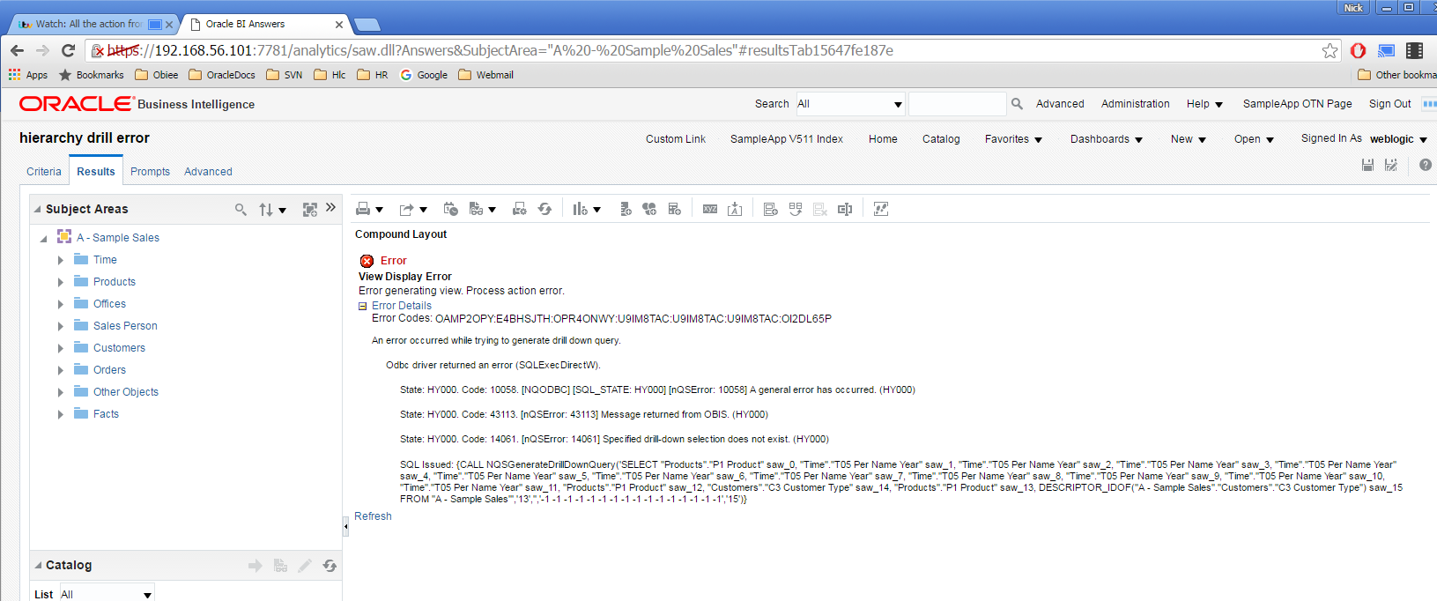

XML

<saw:report xmlns:saw="com.siebel.analytics.web/report/v1.1" xmlns:xsi="http://www.w3.org/2001/XMLSchema-instance" xmlns:xsd="http://www.w3.org/2001/XMLSchema" xmlns:sawx="com.siebel.analytics.web/expression/v1.1" xmlVersion="201201160">

<saw:criteria xsi:type="saw:simpleCriteria" subjectArea="&quot;A - Sample Sales&quot;">

<saw:columns>

<saw:column xsi:type="saw:regularColumn" columnID="c3aa0fa758fdf5b3c">

<saw:columnFormula>

<sawx:expr xsi:type="sawx:sqlExpression">"Products"."P1 Product"</sawx:expr></saw:columnFormula></saw:column>

<saw:column xsi:type="saw:regularColumn" columnID="c8581b569e893ce6b">

<saw:columnFormula>

<sawx:expr xsi:type="sawx:sqlExpression">"Time"."T05 Per Name Year"</sawx:expr></saw:columnFormula></saw:column>

<saw:column xsi:type="saw:regularColumn" columnID="c228c57ca7e4effcf">

<saw:columnFormula>

<sawx:expr xsi:type="sawx:sqlExpression">"Time"."T05 Per Name Year"</sawx:expr></saw:columnFormula></saw:column>

<saw:column xsi:type="saw:regularColumn" columnID="c522b0f8372e8a24c">

<saw:columnFormula>

<sawx:expr xsi:type="sawx:sqlExpression">"Time"."T05 Per Name Year"</sawx:expr></saw:columnFormula></saw:column>

<saw:column xsi:type="saw:regularColumn" columnID="ce154af19958374ba">

<saw:columnFormula>

<sawx:expr xsi:type="sawx:sqlExpression">"Time"."T05 Per Name Year"</sawx:expr></saw:columnFormula></saw:column>

<saw:column xsi:type="saw:regularColumn" columnID="c4b3a06b1de4888d4">

<saw:columnFormula>

<sawx:expr xsi:type="sawx:sqlExpression">"Time"."T05 Per Name Year"</sawx:expr></saw:columnFormula></saw:column>

<saw:column xsi:type="saw:regularColumn" columnID="cb4ac04df382cda58">

<saw:columnFormula>

<sawx:expr xsi:type="sawx:sqlExpression">"Time"."T05 Per Name Year"</sawx:expr></saw:columnFormula></saw:column>

<saw:column xsi:type="saw:regularColumn" columnID="c0cfcf199b95ad2b4">

<saw:columnFormula>

<sawx:expr xsi:type="sawx:sqlExpression">"Time"."T05 Per Name Year"</sawx:expr></saw:columnFormula></saw:column>

<saw:column xsi:type="saw:regularColumn" columnID="c7e3c932f62f19f0e">

<saw:columnFormula>

<sawx:expr xsi:type="sawx:sqlExpression">"Time"."T05 Per Name Year"</sawx:expr></saw:columnFormula></saw:column>

<saw:column xsi:type="saw:regularColumn" columnID="c68096a8d90a6c995">

<saw:columnFormula>

<sawx:expr xsi:type="sawx:sqlExpression">"Time"."T05 Per Name Year"</sawx:expr></saw:columnFormula></saw:column>

<saw:column xsi:type="saw:regularColumn" columnID="c291a63a30106220f">

<saw:columnFormula>

<sawx:expr xsi:type="sawx:sqlExpression">"Time"."T05 Per Name Year"</sawx:expr></saw:columnFormula></saw:column>

<saw:column xsi:type="saw:regularColumn" columnID="cc7df59cbd6f060ea">

<saw:columnFormula>

<sawx:expr xsi:type="sawx:sqlExpression">"Time"."T05 Per Name Year"</sawx:expr></saw:columnFormula></saw:column>

<saw:column xsi:type="saw:regularColumn" columnID="c79ec9cf732b457d7">

<saw:columnFormula>

<sawx:expr xsi:type="sawx:sqlExpression">"Products"."P1 Product"</sawx:expr></saw:columnFormula></saw:column>

<saw:column xsi:type="saw:regularColumn" columnID="ccb9d42a5b3861d09">

<saw:columnFormula>

<sawx:expr xsi:type="sawx:sqlExpression">"Products"."P1 Product"</sawx:expr></saw:columnFormula></saw:column>

<saw:column xsi:type="saw:regularColumn" columnID="c194cc73304876c0c">

<saw:columnFormula>

<sawx:expr xsi:type="sawx:sqlExpression">"Customers"."C3 Customer Type"</sawx:expr></saw:columnFormula></saw:column></saw:columns></saw:criteria>

<saw:views currentView="0">

<saw:view xsi:type="saw:compoundView" name="compoundView!1">

<saw:cvTable>

<saw:cvRow>

<saw:cvCell viewName="titleView!1"/></saw:cvRow>

<saw:cvRow>

<saw:cvCell viewName="tableView!1"/></saw:cvRow></saw:cvTable></saw:view>

<saw:view xsi:type="saw:titleView" name="titleView!1"/>

<saw:view xsi:type="saw:tableView" name="tableView!1" scrollingEnabled="true">

<saw:edges>

<saw:edge axis="page" showColumnHeader="true"/>

<saw:edge axis="section"/>

<saw:edge axis="row" showColumnHeader="true">

<saw:edgeLayers>

<saw:edgeLayer type="column" columnID="c3aa0fa758fdf5b3c"/>

<saw:edgeLayer type="column" columnID="c8581b569e893ce6b"/>

<saw:edgeLayer type="column" columnID="c228c57ca7e4effcf"/>

<saw:edgeLayer type="column" columnID="c522b0f8372e8a24c"/>

<saw:edgeLayer type="column" columnID="ce154af19958374ba"/>

<saw:edgeLayer type="column" columnID="c4b3a06b1de4888d4"/>

<saw:edgeLayer type="column" columnID="cb4ac04df382cda58"/>

<saw:edgeLayer type="column" columnID="c0cfcf199b95ad2b4"/>

<saw:edgeLayer type="column" columnID="c7e3c932f62f19f0e"/>

<saw:edgeLayer type="column" columnID="c68096a8d90a6c995"/>

<saw:edgeLayer type="column" columnID="c291a63a30106220f"/>

<saw:edgeLayer type="column" columnID="cc7df59cbd6f060ea"/>

<saw:edgeLayer type="column" columnID="c79ec9cf732b457d7"/>

<saw:edgeLayer type="column" columnID="c194cc73304876c0c"/>

<saw:edgeLayer type="column" columnID="ccb9d42a5b3861d09"/></saw:edgeLayers></saw:edge>

<saw:edge axis="column" showColumnHeader="rollover"/></saw:edges></saw:view></saw:views>

<saw:prompts scope="report" subjectArea="&quot;A - Sample Sales&quot;"/></saw:report>

SQL

SET VARIABLE PREFERRED_CURRENCY='USD';SELECT

0 s_0,

"A - Sample Sales"."Customers"."C3 Customer Type" s_1,

"A - Sample Sales"."Products"."P1 Product" s_2,

"A - Sample Sales"."Time"."T05 Per Name Year" s_3,

DESCRIPTOR_IDOF("A - Sample Sales"."Customers"."C3 Customer Type") s_4

FROM "A - Sample Sales"

ORDER BY 3 ASC NULLS LAST, 4 ASC NULLS LAST, 2 ASC NULLS LAST, 5 ASC NULLS LAST

FETCH FIRST 5000001 ROWS ONLY